IML QC Instructions V1

(WIP – ROUGH DRAFT)

# March 2019

## Emily Chisholm

**Step 1 – Data Collection**

Collect data in BCD format

Headers should read:

|  |
| --- |
| [1] "DIS_DATA_NUM" "MISSION" "MISSION_DESCRIPTOR"  [4] "EVENT_COLLECTOR_EVENT_ID" "EVENT_COLLECTOR_STN_NAME" "DIS_HEADER_START_DEPTH"  [7] "DIS_HEADER_END_DEPTH" "DIS_HEADER_SLAT" "DIS_HEADER_SLON"  [10] "DIS_HEADER_SDATE" "DIS_HEADER_STIME" "DIS_DATA_TYPE_SEQ"  [13] "DATA_TYPE_METHOD" "DIS_DETAIL_DATA_VAL" "DIS_DETAIL_DATA_QC_CODE"  [16] "DIS_DETAIL_DETECTION_LIMIT" "DIS_DETAIL_DETAIL_COLLECTOR" "DIS_DETAIL_COLLECTOR_SAMP_ID"  [19] "CREATED_BY" "CREATED_DATE" "DATA_CENTER_CODE"  [22] "INSTITUTE" "PROCESS_FLAG" "BATCH_SEQ"  [25] "DIS_SAMPLE_KEY_VALUE" |
|  |
| |  | | --- | |  | |

Ensure data includes, temp, salinity, nutrient, depths, and all relevant metadata

You should also have a BCS file for the cruise containing the following metadata parameters, although not required for QC is key for archiving.

**Step 2 – Pre Processing in R**

1. Ensure you have a working directory established, with a folder named “IML_QC” for storing IML format files being produced.
2. Make sure package ‘reshape’ is called into your library

* require(reshape)

1. Make sure you have files:

* convertOxy.R (optional for oxygen conversion)
* BCD2IML_format.r
* Get_flags_IML2BCD_EC.r

Note: If QC involves oxygen data in mmol/m**3, convert values to ml/l before running QC using convertOxy.R function.

**Sub Step 2.1 – Converting Oxygen Data**

**Determine which cruises in data set contain data in mmol/m**3 units**

* + 1. **Rename with DATA_TYPE_METHOD set to O2_Winkler_Molar to distinguish between measurement units**

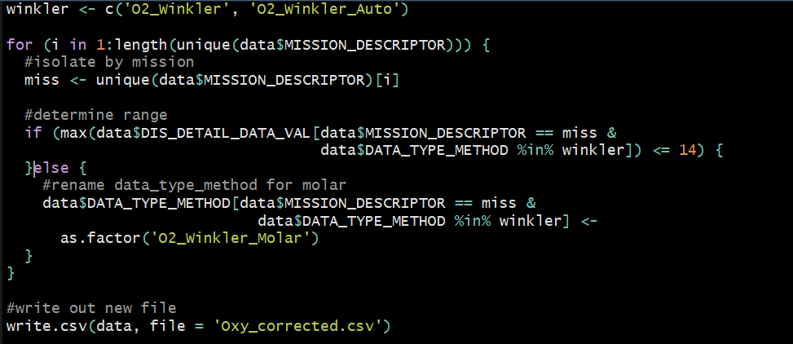

* + 1. Run convertOxy.R function inside loop of BCD2IML_format.R

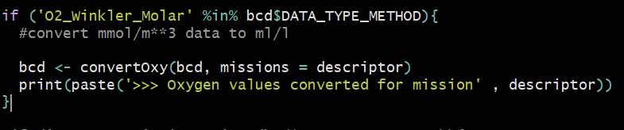

* + 1. Oxygen can then be run through QC in ml/l and flags will map back to original mmol/m**3 data (no rounding or conversion errors in data set)

1. Ensure BCD_IML_map_upd.csv includes all data types that are present in your data set mapping to appropriate IML codes and units.
2. Ensure sample key value is created properly following standard structure

Eg.

bcdo$DIS_SAMPLE_KEY_VALUE=paste0(bcdo$MISSION_DESCRIPTOR,"_",sprintf("%03d",bcdo$EVENT_COLLECTOR_EVENT_ID),"_",bcdo$DIS_DETAIL_COLLECTOR_SAMP_ID)

1. Loop through BCD2IML_format.r for each cruise included in your data set.

This will create IML format files for each cruise, one for bottle data and one for CTD data, in a folder ‘IML_QC’ inside your working directory

**Step 3 – Processing in MATLAB**

1. Ensure your path includes

* MLI CTD package
* Seawater Package
* Rosette folder with IML QC scripts (modified at BIO)
* You are working out of you IML_QC folder with all your IML formatted data

1. Run file B_batch_BIO.m

Note: ensure you are using B_control_Q_GL.m (modified by Gordana Lazin for BIO) NOT B_control_Q.m

Explain each line of B_bath_BIO.m

1. Move all QC files produced to a distinct folder in working directory (eg. **QC_V1)**

**Step 4 – Post Processing in R**

1. Run through get_flags_IML2BCD_EC.r

This script has been modified since Gordana’s 2016 version with bug fixes and generalizations

Note: ensure that line 67 – change to top of script

# file name with path to the QC data

fnp=file.path(getwd(),"**QC_V1**",fn)

“**BOLD**” is the name of the folder where you have put your IML QC files, specific to your working directory

1. Run plot_profiles.R to get visualization of all flags
2. Use bcdFlag_reviewTable.R to create a review table for flags produced from IML QC
3. Edit and update these flags as required, using ‘REVIEWED_DATA_QC_CODE’ and ‘COMMENT’ columns
4. Use bcdFlag_reviewUpdate.R to update the flagged BCD file for each cruise using the reviewed data QC codes from the flagged_Review csv file

**Step 4 - Summary**

1. Each cruise folder should contain
   * a BCD and BCS file
   * A flagged BCD file
   * A flag review file with edits and record of original flag and any comment by flag reviewer
   * a flag summary
   * a reviewed flag summary
   * a flag report
   * plotted profiles for each event which was flagged
2. Check IMLTroubleshooting guide if errors are encountered